Help expand Hamilton’s History Timeline exhibition!

You have a role to play in highlighting Hamilton’s past, present and future. Send us your content contributions and help us expand the timeline content.
The land we now call Hamilton has a multifaceted history. In this infinitely expandable timeline interface we built for Hamilton 175 digital commemorations in 2021, YOU have a role to play in highlighting Hamilton’s past, present and future. Send us your content contributions to add to Hamilton’s History Timeline and browse other historic events crowdsourced from the community.
  - >>> How can you share?
Share historic events that are relevant to your community and Hamilton’s history. Use this form to submit your content to museums@hamilton.ca.
  - >>> What to share?
Visit the exhibition and explore the event entries there –what’s covered? What’s missing? What does an entry look like?
We that that there’s a lot that one can say about a historic event! Timeline entries are meant to be brief summaries of the event, but with enough details to pique your curiosity to explore other sources to learn more.
We’re also looking for entries with supporting visuals to illustrate the text. For example, photos, videos, audio, etc. They can be links to existing sources, such as a photo from the Hamilton Public Library or from your personal collection (we’ll need permission to use it). Please send large files through a cloud service like DropBox or WeTransfer.
If you already have a timeline developed or historical information available in a different format, please email us.
The image below is an example of what an event entry looks like
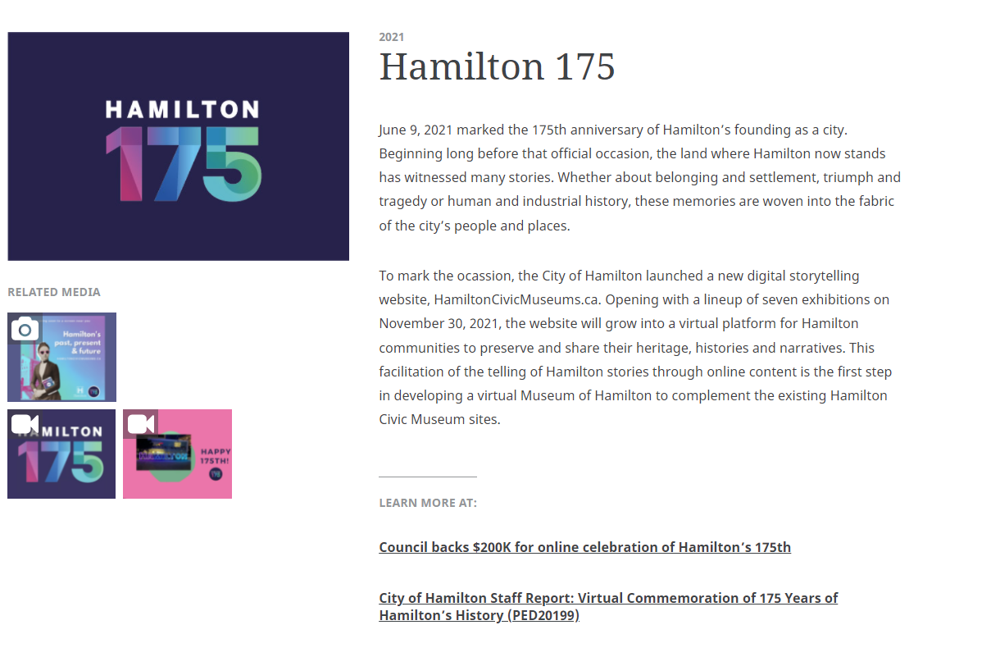

Complete the following information for each event entry

Event title
For example: Brightside Hotel Demolition

When did it happen? (exact date, start date or date range)
For example: 1940, December 1940, 15 December 1940

What was the historic event about? (100 words)
Please provide a short description

Why is it important to the city’s history and the people of Hamilton? (50-75 words)
Relevance of this historic event

Multimedia: Photos, Videos, Audio
Please note that we will require permission to use any content you provide. The content will need to be free from copyrights (i.e. in the public domain) or, if you own it, we'll ask for your permission to use and credit.

- Provide supporting photos or graphics (5 max)
- Provide supporting videos (2 max)
- Provide supporting audio files (2 max)
- Please send large files through a cloud service like DropBox or WeTransfer

Copyrights: Can we use the multimedia content you provided? Choose
- I don't know
- Images are public domain and free to use
- I own these images and can provide permission to use
- Other:

Where can people learn more about the event?
Provide links to external sources. For example, an exhibition, archive, book, organization, etc.

Is there a location in the city to visit?
Provide the address. For example: heritage plaque location, site, park, etc.

Who Submitted this entry?

Your name & Organization (if applicable)

How can we contact you? (email or phone)

